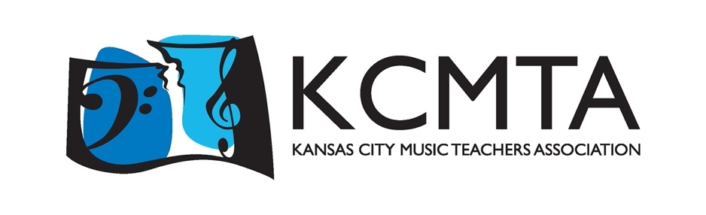

2025 Multi-Piano Parent Ads

Congratulate your student with a personalized message in this year’s Multi-Piano program! Students love seeing their names in print, and what better way to recognize them for their hard work than a message in the program telling them just how proud they have made you? Your student will find a special surprise on concert day and your contribution will help ensure the future of this exciting event.

Messages may contain up to 30 words at a cost of $15.

***All messages and payments must be submitted by December 1, 2024***

Payment Methods
  - PayPal: KCmusicteachers@gmail.com, then email this form to e.m.wohlgemuth@gmail.com
  - Check: Payable to KCMTA – mail both the check and the below advice to:
Emma Wohlgemuth
241 NW Kessler Drive, Apt. 307
Lee’s Summit, MO 64081

Thank you for your dedication to your child’s study of music and your support of the Multi-Piano Concert!
------------------------------------------------------------------------------------------------------------------------------------
2025 Multi-Piano Parent Ad Remittance Advice

Student Name(s): _________________________________________________________________________

Parent Name(s): __________________________________________ Date: ________________________

Phone Number: _________________________ Email: ___________________________________________

Address: _________________________________________________________________________________

☐Paid with check ☐Paid via PayPal Amount Enclosed: $____________________

Please write your message as you would like it to appear in the program. Messages may contain a maximum of 30 words, not including parent and student names.

Message: _________________________________________________________________________________

__________________________________________________________________________________________

__________________________________________________________________________________________

__________________________________________________________________________________________

