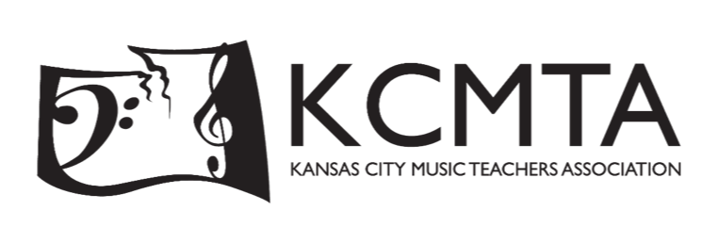

Dear [INSERT NAME],

On January 5, 2025, the Kansas City Music Teachers Association will present the 28th Multi-Piano Concert with the theme “Dance With Me”. This concert features duet teams from throughout the KC Metropolitan area performing as a piano orchestra on 11 grand pianos under the direction of professional conductor, Chad Reed.

Besides being a wonderful concert experience, this is also a unique advertising opportunity for your business. Our performers are required to be backstage half an hour before the concert begins. That means most families will be in their seats for 30 minutes before the concert. This gives you the opportunity to reach a truly “captive” audience, during our pre- and post-concert slideshow.

KCMTA would like to offer you an opportunity to be a sponsor for this unique event.

We have three levels of sponsorship:

Performer Level
- Investment: $200
- Half-page ad (5.5” x 4.25”) in the printed program
- Repeating slide during our pre- and post-concert slideshows
Conductor Level
- Investment: $400
- Full-page ad (5.5” x 8.5”) in the printed program
- Repeating slide during our pre- and post-concert slideshows
Virtuoso Level
- Investment: $600
- Full-Page ad (5.5” x 8.5”) in the printed program
- Repeating slide during our pre- and post-concert slideshows
- Four complimentary concert tickets

As a nonprofit organization, your support is greatly valued. Events like our Multi-Piano concert would not be possible without contributions from outstanding pillars of our community like yourself.

Thank you for considering participating in this unique event. I hope to hear from you soon.

Sincerely,

Emma Wohlgemuth
KCMTA Vice President Multi-Piano

MULTI-PIANO CONCERT SPONSHORSHIP FORM

Guidelines and Instructions

Payment Methods
  - PayPal: KCmusicteachers@gmail.com, then email this form to e.m.wohlgemuth@gmail.com
  - Check: Payable to KCMTA – mail both the check and the below remittance advice to:
Emma Wohlgemuth
241 NW Kessler Drive, Apt. 307
Lee’s Summit, MO 64081

Advertisement Format
- Program Ads: Black & White
- Slideshow Ads: Black & White OR Color

Advertisement Submission
- Email chosen sponsorship, program, and slideshow advertisement(s) in PDF format to:
Emma Wohlgemuth at e.m.wohlgemuth@gmail.com

The advertising deadline for the 2025 concert program is November 1, 2024.

Thank you for your support!

------------------------------------------------------------------------------------------------------------------------------------

2025 Multi-Piano Sponsorship Remittance Advice

Company, Organization, or Individual: _________________________________________________________
(as it is to appear in the program and in the slideshow)

Name: _____________________________________ Date: ________________________

Address: _________________________________________________________________________________

Email: ____________________________________ Phone Number: ____________________________

Sponsorship Level:
- Performer: $200 Signature: ________________________________
- Conductor: $400
- Virtuoso: $600 Amount Enclosed: $__________________

