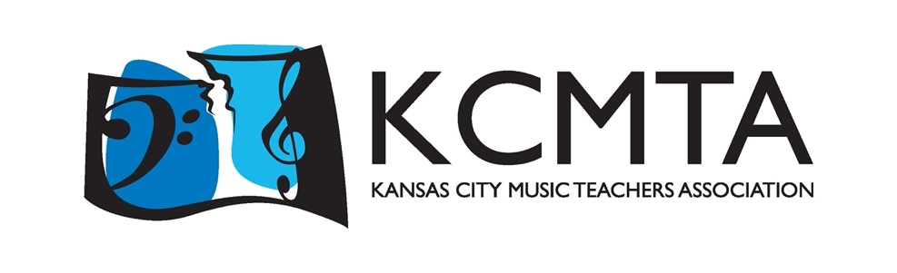

2026 Multi-Piano Concert Order
“Heroes and Villains”
pieces are listed in order as concert sets

A Suspenseful Situation & A Bell Carol

For Good

Superhero Scherzo & Beethoven’s Ghost

A Mysterious Adventure & Hometown Celebration

The Sorcerer’s Dream

Yo Ho (A Pirate’s Life for Me) & If I Only had a Brain

Eine Kleine Nachtmusik & Morning

Star Wars & Over the Rainbow

Inspector Gadget

We’re Off to See the Wizard & The Pink Panther

Musetta’s Waltz & Queen of the Night Aria

The Imperial March & Cruella de Vil

The Little Tin Soldier

Popular

America the Beautiful & Sleeping Beauty Waltz

Dueling Fingers & Egyptian Princess

Rhapsody Grandioso

